<Bulk Submit>
<Bids and offers>

Table of Contents
1. Overview 1
2. Components in Bulk Submit Screen 2
A. Ribbon Menu 2
1. Export 3
2. Query Inputs 3
3. Actions 4
4. Layout Manager 4
5. Favorite 4
B. Bulk Submit Table 5
3. Actions to perform in the Bids Screen 6
A. Bulk Submitting to ISO 6
B. Cancelling Bulk Submission 8

Overview
The Bulk Submit screen allows you to submit multiple bids, offers, or schedules to an Independent System Operator (ISO) in a single action. This feature streamlines the process for managing market interactions and is especially useful when working simultaneously with multiple participants, assets, or market types.
By centralizing all key parameters such as date and time range, participant groups, assets, market type, and ISO selection, the Bulk Submit screen improves operational efficiency, ensures submission consistency, and reduces the risk of manual errors.
The Bulk Submit Table displays transaction details after submission, allowing you to review and verify results.
Bulk submission helps you:
- Save time on repetitive market submissions.
- Reduce errors by standardizing inputs.
- Maintain consistency across large portfolios or recurring market strategies.
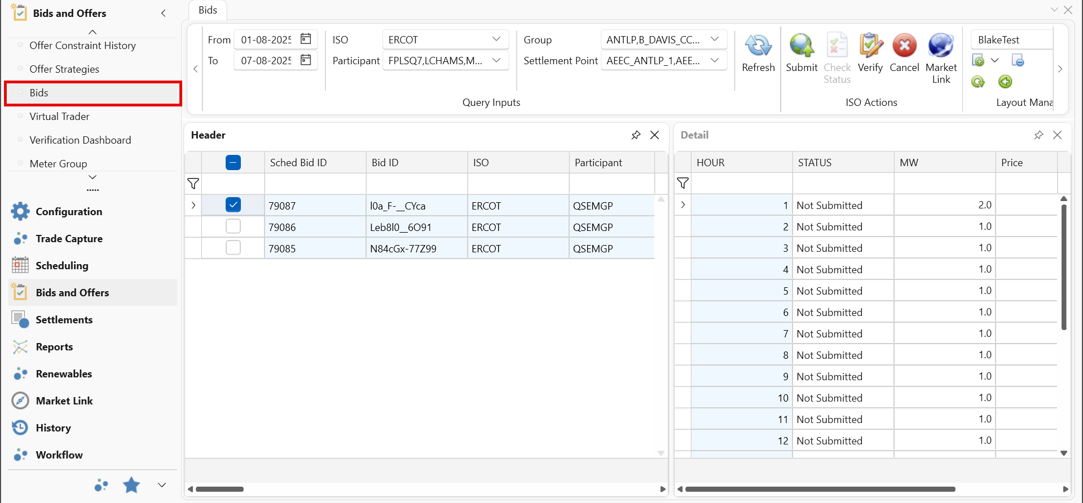

Components in Bulk Submit Screen
The Bulk Submit screen features interactive components that enable you to define, execute, and monitor multiple market submissions in one place.
From the Ribbon Menu, you can select the date range, ISO, start and end hours, participant group, participants, group, assets, market type, and submission group. You can then submit or cancel submissions, monitor status messages, and review transaction details in the Bulk Submit Table.
The main components are as follows:
- Ribbon Menu
- Bulk Submit Table

Ribbon Menu
The Ribbon Menu provides centralized controls for defining submission parameters and executing bulk actions. Located at the top of the interface, it is divided into functional sections for quick access: Export options for saving or sharing submission data, Query Inputs for selecting the parameters for submission to ISO, and Actions for submitting the selected parameters to ISO or cancelling submissions.
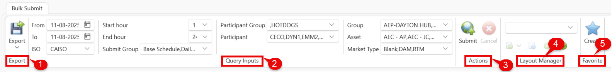
The Ribbon Menu includes the following sections:
- Export
- Query Inputs
- Actions
- Layout Manager
- Favorite

Refer to the following specifications for group functionalities in the Ribbon Menu.

Export
The Export function allows you to save or share submission data for reporting, analysis, or record-keeping.
Buttons | Description
Export | Allows you to download the Bulk Submit data in CSV or XLSX format.

Query Inputs
The Query Inputs section allows you to define the key parameters required for bulk submission. Once these parameters are set, users can submit or cancel bulk submissions for the selected ISO.
Buttons | Description
From/To | Selects the date range for the submission period.
ISO | Selects the target Independent System Operator (ISO) market.  NOTE: The dropdown options for the fields below are dynamic and updated based on the selected ISO.
Start Hour / End Hour | Specifies the hourly range (within the selected date range) for submission.
Submit Group | Selects the bulk submission group.
Participant Group | A predefined group of market participants to include in the submission.
Participant | Identifies the market participant or bidding entity.
Group | A logical grouping of assets for submission.
Assets | The specific asset(s) for which bids will be submitted.
Market type | The market in which the submission will be placed.

Actions
The Actions section in the Bulk Submit screen provides the controls to execute the bulk submission process and cancel an in-progress submission.
Buttons | Description
Submit | Sends the selected bids to the ISO for processing.
Cancel | Withdraws or cancels ISO processing that was submitted.

Layout Manager
The Layout Manager allows you to customize the arrangement of columns in the Bid Submission screen and save the configuration for future use.
Buttons | Description
Select Layout | Displays a list of previously saved layouts.
Save Layout | Saves the current layout configuration.  Note: The user can save the layout as Private or Public from the dropdown.
Delete Layout | Deletes the currently selected layout.
Reload | Reloads the currently active layout.
Restore Default Layout | Restores the layout to its default configuration.

Favorite
The Favorite feature lets you save frequently used parameter settings in the Query Inputs section for quick reuse, reducing the need to re-enter values each time.
Buttons | Description
Create | Saves the current ribbon values as a favourite configuration for future reuse. This allows quick loading of frequently used input settings in the Ribbon menu.

Bulk Submit Table
The Bulk Submit Table displays the records of bids submitted for the selected ISO and query parameters.
Buttons | Description
(Checkbox) | Selects the bid row to perform several actions.
Sched Bid ID | Displays the scheduled bid identifier generated by the system.
Bid ID | Identifies the bid for submission to the ISO.
ISO | Shows the name of the ISO.
Participant | Indicates the market participant associated with the bid.
Operating Date | Specifies the date on which the bid is valid and active.
Expiration Time | Shows the time when the bid expires in the ISO market.
Transaction ID | Provides the reference number returned by the ISO after submission.
Market Type | Displays the market type for the bid, e.g., Day-Ahead Market (DAM).
Bid Type | Indicates the type of bid (e.g., PTP Obligation).
Settlement Point | Shows the settlement locations where the bid is applied.
Sink Point | Indicates the sink location for the bid.
Buyer | Displays the buyer associated with the bid.
Seller | Displays the seller associated with the bid.
Trader | Displays the trader responsible for the bid.
Strategy | Shows the name of the strategy applied to the bid.
Status | Indicates the bid status (e.g., Not Submitted, Submitted, New).
Verification | Displays whether the bid has been verified.
Verify Date | Displays the date when the bid was last verified.
Total | Shows the total megawatts (MW) in the bid across all hours.
HE01–HE24 | Displays the MW for each hour of the operating day

Actions to be performed in the Bids Screen
The Bulk Submit screen puts all essential submission tools in one place, giving you complete control over high-volume market activities. From here, you can submit bids directly to an ISO, cancel submissions in progress, export and analyse your results, customize and save your preferred table layout, and store frequently used parameters as Favorites for one-click reuse. This all-in-one feature saves time, reduces errors, and keeps your market operations running smoothly.
- Bulk Submitting to ISO
- Cancelling Bulk Submission

Bulk Submitting to ISO
Use this procedure to submit bulk data to a selected ISO for specific participants, groups, and assets within a defined date and time range. You can access the Bulk Submit screen from the Bids & Offers module.
Follow the steps below to submit the selected parameters to ISO.
- Configure the required fields in the Bids screen, within the Query Inputs section of the ribbon menu.
- From: Select the start date for the submission period.
- To: Select the end date for the submission period.
- ISO: Choose the ISO (e.g., AESO, MISO, PJM).
- Start hour: Select the hour when the submission should begin.
- End hour: Select the hour when the submission should end.
- Submit Group: Select the bulk submission group.
- Participant Group: Choose the relevant participant group. The dropdown updates dynamically based on the selected ISO.
- Participant: Select the market participant responsible for executing the strategy. The dropdown updates dynamically based on the selected ISO.
- Group: Choose the resource group to which the strategy applies.
- Settlement Point: Choose the settlement point.
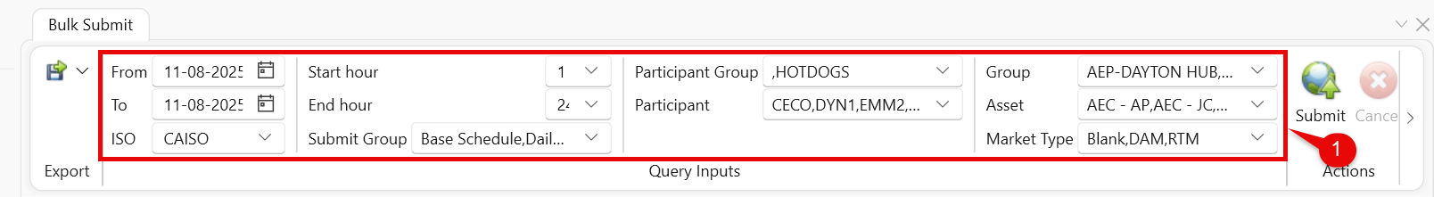
- Click Submit to send the bulk submission request to the ISO.
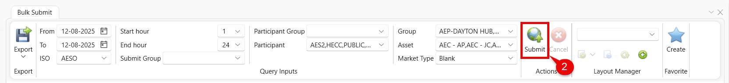
- Review the status messages in the message panel for debugging, warning, info, or error message counts.
The log of process items would appear in the Bulk Submit table.

Cancelling Bulk Submission
Cancelling Bulk submission allows you to withdraw bids that have been submitted or are in preparation, preventing them from being processed in the selected ISO market. This action helps correct errors, adjust bid strategy, or respond to changes in market conditions.
- Begin a bulk submission as described in Bulk Submitting to ISO. While the submission is in progress, review the selected parameters to ensure they are correct.
- If you find an error or no longer require the submission, prepare to stop it before it completes.
- On the ribbon menu, click Cancel. The system stops processing any remaining records.
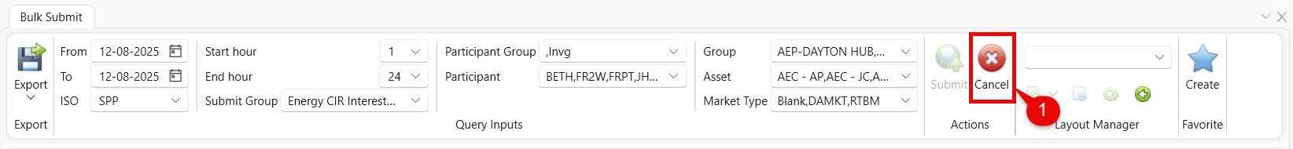
- In the Bulk Submit Table, verify which records were processed before cancellation. Unprocessed records will not appear in the table.
- Update the parameters as needed, then follow the steps in Bulk Submitting to ISO to restart the process.
NOTE: You can only cancel while the submission is in progress. Once it is completed, the Cancel button will be disabled.

